Minutes Plenary Session for Workshop 2

TRACES Mid-term Meeting

Tuesday, 26th September 2017

Workshop 2: „Analysing encounters with difficult collections“

Moderation: Nora

Chair: Gisela

Introduction by Nora Landkammer: Invites presenter of the working groups to say one sentence about the material, to give a brief summary of the most relevant thesis as well as possible connections between the different working groups - all not longer than 2-5 minutes.

Working group 1

Presenter: Julie

Material: Incident during a workshop in Medias (CCP1)

Thesis 1: -> A man in a position of power subverts a positive object, transforming it into a contentious piece.

Thesis 2: -> He does this by performing incorrect knowledge, using the object to trigger age-old anti-semitic codes.

Thesis 3: -> A power vacuum is created in which the mediators are taken aback, perplexed and feel helpless - this puts under a new form of social pressure.

For future intervention: -> Transfer energy from authoritarian figure

-> Activate/observe audience

-> Return object to its dialogical potential

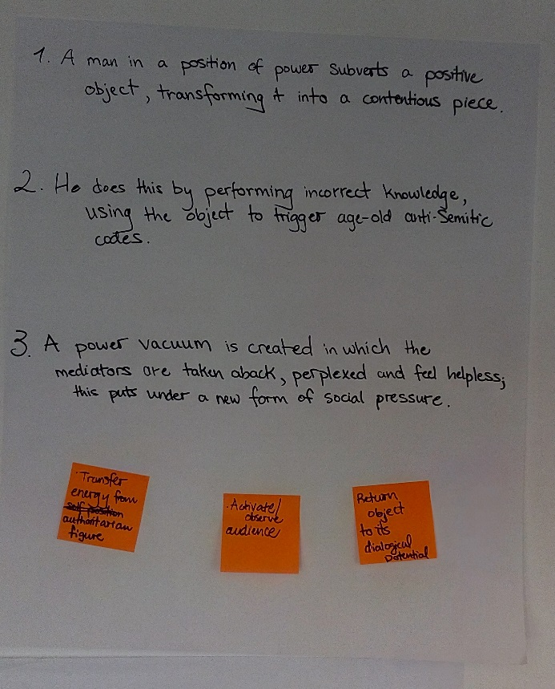

Photo: M. Hamm

Working group 2

Presenter: ???????? (Erica?)

Material: Abandoned collection of Holocaust art (CCP2)

Thesis 1: -> Problematize conditions and decisions for accession and deaccession of objects.

What impacts on knowledge production/practice/politics/status of institution/tourism/economics?

How does this relate to the right to heritage and censorship?

How does this relate to needs for education?

Thesis 2: -> Develop sustainable, critical partnerships (universities, communities)

For future intervention: -> Document sessions - use that for questions on global problems

What do they do to heritage?

What is visible/invisible?

- >Problem of representing heritage

Working group 3

Presenter: Joan

Material: Interview transcript from CCP3; Context: Slovenian dialect - transcribed in English

Thesis: -> What is contentious: - What is difficult (contentious) with dealing with the dead body?

-> Translation: How to deal w ith different languages/native speakers/dialects/transcripts/ editing processes?

-> Personal relations to the content (scientists, relatives…) - how can you deal with different readings from different perspectives (How can you interact with a text? e.g.: experienced ethnographer)

-> Relation: Objectification - Subjectification

For future intervention: - What is contentious as such?

- How to deal with different languages?

- What about different approaches?

Working group 4

Presenter: Nora???

Material: Transcript of memory- and observation logs from CCP?/WP2???; pupils interviewed on „What is this doing here?“

Thesis: -> Objects are not perceived as contentious - they are made contentious

-> Shift of responsibility because of not knowing: Who should know something about it? - Who is the owner of the object?

-> Responsibility goes along with ownership (They are involved, because they own it!)

-> Uncertainty and the crucial points of knowing/not knowing (importance of communication)

For future intervention: -> Raise awareness about contentiousness/contentious objects

-> Think about all stakeholders (curators, politicians,…)

-> Think about kids and how to involve them

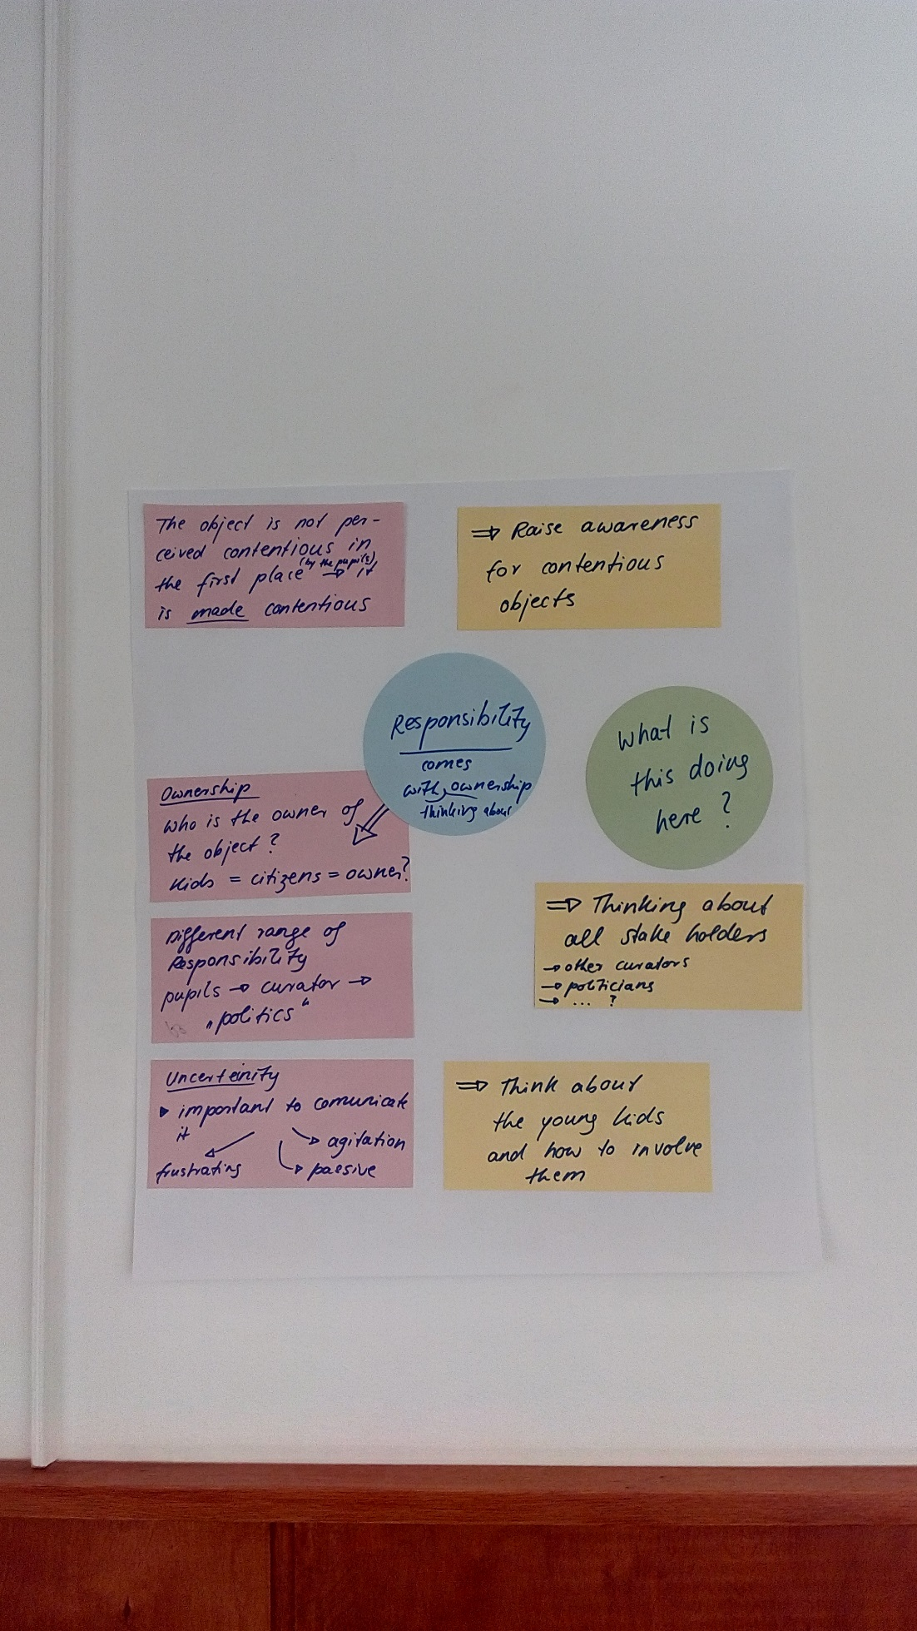

Photo: M. Hamm

Working group 5

Presenter: Aglaja

Material: Written document of Tal Adlers first encounter with the skull exhibition in Vienna (CCP4)

Thesis: -> Transformation from object to individual subject can render (e.g.: by describing of an observer) something contentious

-> Affects and politics - we know it’s contentious because of politics; circular relationships between hiding/revealing and lack of information

-> Contentiousness is socially constructed

For future intervention: ->Who makes decisions?

-> Being aware of the construction of contentiousness

-> Recognize different individuals being involved

->Where and how does the transformation from object to subject happen?

Working group 6

Presenter: Alexandra

Material: Prison art - thatched cottage with white-washed walls (CCP5)

Thesis: -> What makes it contentious? context, in which the object was made - Prison

material which was used (made out of the prison)

creator being a loyalist, as contentious subject position, while the motive can be seen as symbolising “Irishness”

The artists interaction with the object – offer to fix it, picking it up at loyalist venue, issues of trust, correct restauration, artistic care

-> Who makes it contentious? stakeholders

the other party

-> How is contentiousness avoided? person who makes this

state who does not know what to do with the building

For future intervention: -> An object is an object - it depends who is looking at it in which context

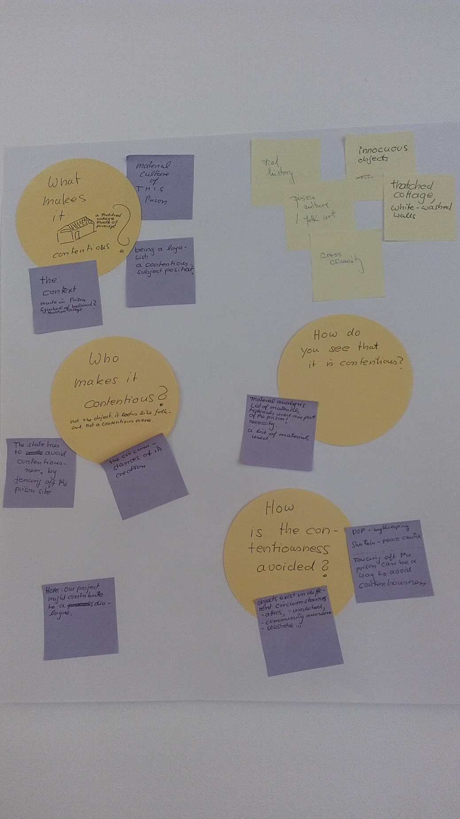

Photo: M. Hamm

Working group 7

Presenter: ???

Material: Encounter with a zoological curator in Rome (WP2)

Thesis: -> Avoidance strategies: to ask for dealing with colonial past (curator reframes undigested colonial remains or knowledge by universalizing a general problem)

-> Sectorial knowledge (curator only asks how the collection fits into zoology - different framing of what the problem is about?)

->Reworking the past from other contexts to Italian colonialism (Germany)

For future intervention: -> Being direct in interactions

-> Point out the problem

-> How can the strategies be communicated?

Final statements

Janet Marstine (EAB):

- Do you have a set of values? To articulate values all are dealing with in a public way could help to push the project. Framing through ethics of care.

* Empower stakeholders to engage in ways that are meaningful for them.

Robin Boast (EAB):

- Be aware of all controversy.

- Try to be radical - even by doing an EU-project. Subjects need radical thinking.

- There was a third point which the minute-taker did not get.