Minutes Plenary Session for Workshop 4

TRACES Mid-term Meeting

Wednesday, 27th September 2017

Workshop 4: „Making sense of field materials: Mobilising ethnographic methods to understand contentious heritage and creative co-production in trans-disciplinary heritage work“

Workshop prepared by WP2 and WP4.

Moderation: Marion

Chair: Karin

Working groups presented their results in form of posters.

Working group 3 - Meaningful Materialities

Material: Images provided by CCP3 & CCP5, plus edited transcript in English language of interview conducted in Slovenian (CCP3)

Group led by Arnd

Tal: Recommends William Crawford - the syntax of image (each medium has a certain syntax) . Before we start to talk, we have to talk about material. Everything (visible as well as invisible) is curated and different from what we see. Mentions Ariella Azoulays work to explain that all things shown on a picture are situated in power relation. Same for texts. We have to reflect all the before done composition (manipulation).

Aglaja: Actual ethnographic material compresses all of that - contentiousness happens, when multiple perspectives come together. Whatever records we produce - they simplify.

Discussion: Is composition only relevant for images, or also for text?

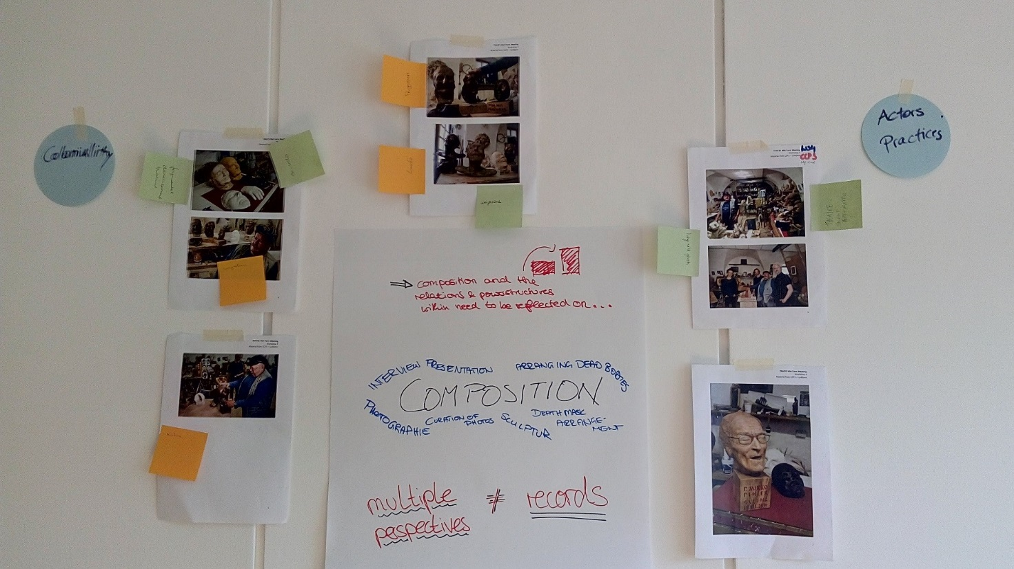

Poster WS4, WG3. Photo: M. Hamm

Working group 1 - Reading between the lines

Material: Parts of an interview with a collector (CCP2)

Group led by Marion

Alexandra: The feelings during the first step of discussion were dominated by confusion, irritation and anger. Part of the interview was about a figurine depicting a mother holding a child. A photo of the figurine was published in a volume with the caption: Mother protests against genozide. The volume was published in GDR. Interviewer tried to find out who came up with the title and why.

The respondent avoided questions he was asked and did not really answer.

Background question: Why would someone own a collection like this?

The respondent talked about his past. He mentioned having been in the Hitler Youth and explained that otherwise his father would have been executed. Analysis of interviewer: He made excuses: „I was forced to do so.“

Universal theme: Artist has to do so.

Alexandra reads out a short passage of the interview to demonstrate the complexity of a sentence which illustrate the complexity of the entire situation.

Erica: Need to be reflexive and acknowledge different subject positions.

Talking about the interview helped her to see that respondent re-enacted his past in the interview situation without her asking for it

Marion: Fixing position - almost falling in same trap as respondent - different subject positions

Erica: Cannot see contentiousness.

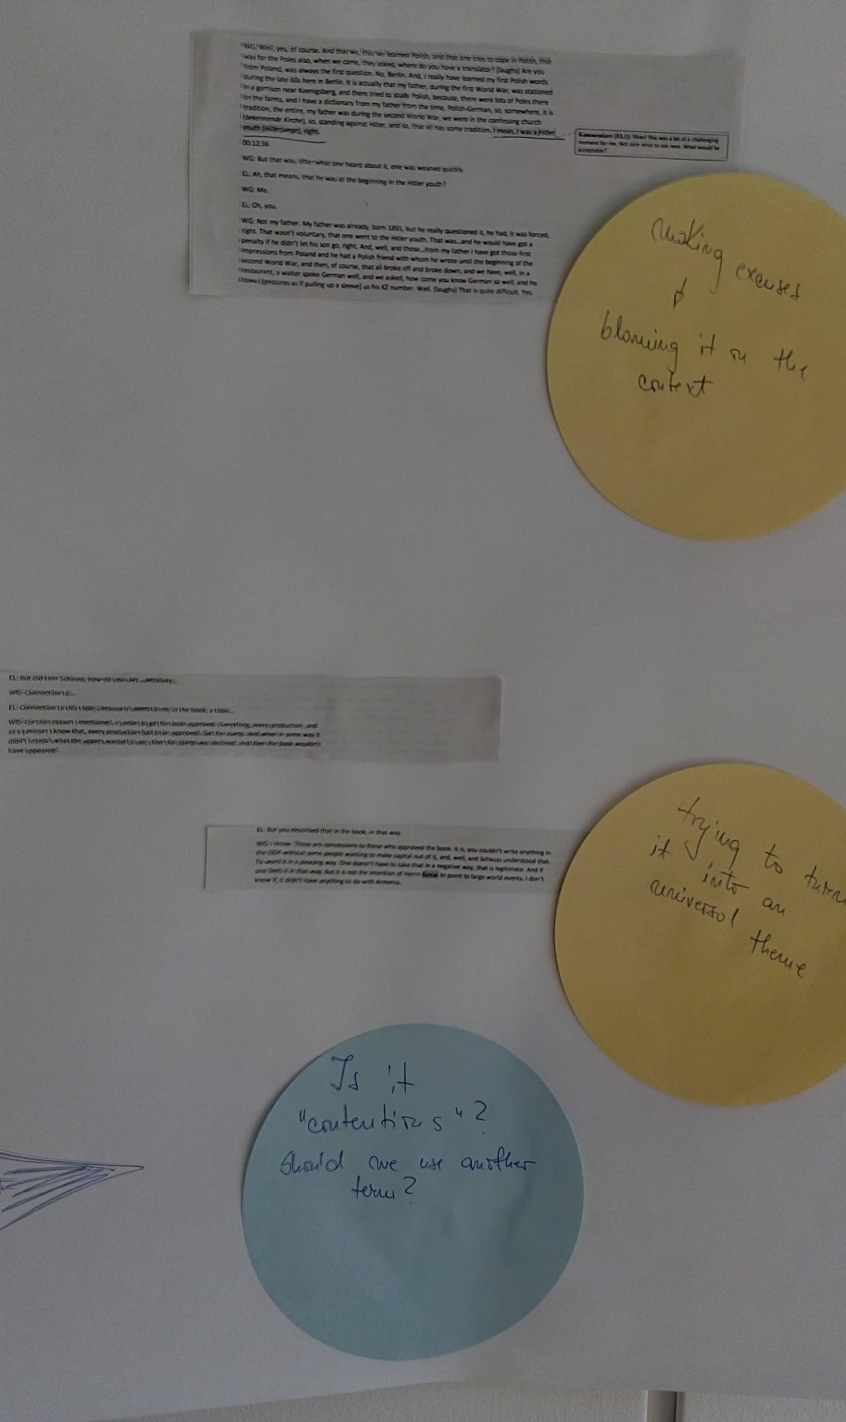

Poster WS4, WG1, photo by M. Hamm

Working group 2 - Reflecting with visuals

Material: Photos from Medias provided by CCP1

Group led by Klaus

Julie: Background information for the picture with the bookshop: Manifesto of Corneliu Codreau, the leader of the right-wing iron guard during WW 2 was exhibited in a bookshop window in Medias next to other books. The group members felt sympathy for the bookshop, confusion about the mixed-up window with the mixed up books. Most important for the group is the incoherence in public space, incoherence by public of historical gravity and the harmless positioning of the book, which makes it contentious.

Maybe the absence of awareness is symptomatic for the situation in Medias.

Alexandra: Mentions the incoherence, non-simultanfeity, subliminal readings.

Julie: Contentiousness can only be perceived with background information.

Marching youth: Upcoming feelings like uncomfortableness, satisfaction or fascination for the lack of public enthusiasm. - The ambivalence of the audience as indicator for the peoples unawareness of the conceptualization.

“Jewish bath” – inscription on shopfront of a workspace in Medias, in the building that used to house the Jewish bath: The background information given by Julie and Alexandra unfolds the story of a young fman who wants to show some history in his company but who is not versant or aware of the historical background. The group did not get over the step of gathering their emotional responses - feelings like confusion, disturbance, incomprehensibleness.

Karin: Asks for something to round up.

Klaus: The last picture is really disturbing

Karin: Generalisation?

Marion: Maybe a good picture - can carry a lot in an analytical way. Contextualizing - so that reader understands.

Erica: They/we do have different contexts.

Marion: Different from all other - social power structure - has to be made contentious

Klaus: We need to see contradiction in all - with all actors. We have to analyze along a guideline. In Medias we have to accept. Perhaps we look at narratives. We have to understand and accept it: it is about context.

Karin: A great composition

Marion: Parallels - curated images: multiple perspectives; formats in very different ways; like skulls in the shelves; it is made scientific - language for materiality and text

Tal: Running a text through Google translate twice - equivalent: we run immediately through interpretation and take it for granted - theory of image - reading

Marion: Agrees to disagree

Klaus: Of course there are also different materialities - but it’s all about background and context. There doesn’t exist the real and right interpretation! Be aware: Contentiousness is different for different viewers!

Karin: Opens the discussion.

Jani: We have sensible material and have to be careful about what we disseminate.

Aglaia: We can’t know all things - have to find a way to work with that. What do we want to know and what are we using it for? Realness?

Nora: Forms of interpretation; Level of publication of analyzing image in a book - more analogy would make a book with raw data. Interpretation has to be done.

Karin: Two parallel things:

* + 1. less emotional similarities both in text and images; how does it affect our interpretations; very often put out of context
    2. multi-perspective: text-working people have more awareness of text than of an image - other layers of knowledge; theory and practice

Erica: „We“ - both; what different perspective are we bringing in?

Klaus: All that Tal has mentioned is part of analysis; necessary to know, what producer has done - but it’s only one part. publication - public!

Marion: Thanks all!

Tal: We have to make it clearer: no distinction or comparison between text and pictures. When we start to look at it, we can’t know! Materiality is vocabulary of the print: can lead to different reading than the text. Printed image causes more fluctuation of understanding than written text. Different sytaxes - different systems.

Karin: Closes discussion.

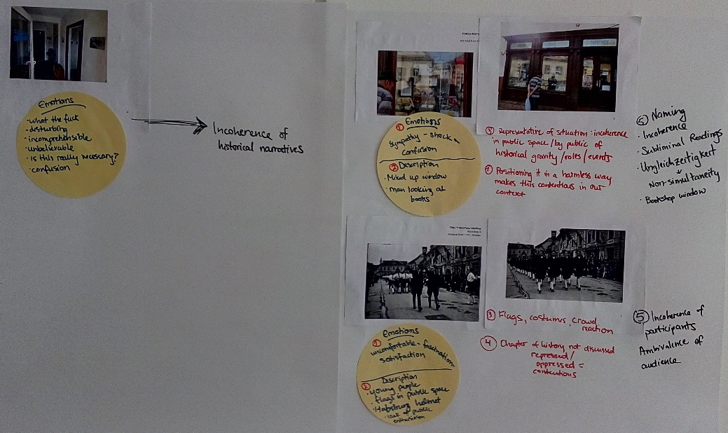

Poster WS4, WG2. Photo: M. Hamm